E-COMMERCE SALES ANALYTICS DASHBOARD
A Project Report Submitted in
the partial fulfillment of the requirements for the award of the degree of
BACHELOR OF TECHNOLOGY
In
DEPARTMENT OF COMPUTER SCIENCE AND ENGINEERING
By
P. Roshan – 2420030701
Om Pandey – 2420030791
P.V.V. Satya Sai – 2420030704
Vadde Tharun Kumar – 2420039804

Under the Esteemed Guidance of
B. Prathusha

Department of Computer Science and Engineering
Course: Engineering Capstone Project – 1 (23IE4053R / 23IE4053A)
AY-2026–2027
Semester: Odd



K L (Deemed to be) University
DEPARTMENT OF COMPUTER SCIENCE AND ENGINEERING

Declaration
The Project Report entitled “E-Commerce Sales Analytics Dashboard” is a record of Bonafide work of P. Roshan – 2420030701, Om Pandey – 2420030791, P.V.V. Satya Sai – 2420030704, Vadde Tharun Kumar – 2420039804 submitted in partial fulfillment for the award of B. Tech in Computer Science and Engineering to the K L University. The results embodied in this report have not been copied from any other departments/University/Institute.

P. Roshan – 2420030701
Om Pandey – 2420030791
P.V.V. Satya Sai – 2420030704
Vadde Tharun Kumar – 2420039804

K L (Deemed to be) University
DEPARTMENT OF COMPUTER SCIENCE AND ENGINEERING

CERTIFICATE
This is to certify that the project based report entitled “E-Commerce Sales Analytics Dashboard” is a bonafide work done and submitted by P. Roshan – 2420030701, Om Pandey – 2420030791, P.V.V. Satya Sai – 2420030704, Vadde Tharun Kumar – 2420039804 in partial fulfillment of the requirements for the award of the degree of BACHELOR OF TECHNOLOGY in Department of Computer Science and Engineering, K L (Deemed to be University), during the academic year 2026-2027.

_____________________  Signature of the Guide  B. Prathusha  Department of CSE | _____________________  Course Coordinator  Department of CSE | _____________________  Head of the Department  Dr. P. Venkateswara Rao  Department of CSE

ACKNOWLEDGEMENT
The success of this project would not have been possible without the timely help and guidance rendered by many people. We wish to express our sincere thanks to all those who have assisted us in one way or the other for the completion of our project.
Our greatest appreciation goes to our Course Coordinator and our guide B. Prathusha, Department of Computer Science and Engineering, for her tremendous support, encouragement and guidance throughout this project.
We express our gratitude to Dr. P. Venkateswara Rao, Head of the Department of Computer Science and Engineering, for providing us with adequate facilities, ways and means by which we were able to complete this project.
We thank all the members of the teaching and non-teaching staff who have assisted us directly or indirectly in the successful completion of this project. Finally, we sincerely thank our parents, friends and classmates for their kind help and cooperation during our work.
P. Roshan – 2420030701
Om Pandey – 2420030791
P.V.V. Satya Sai – 2420030704
Vadde Tharun Kumar – 2420039804

Abstract
The E-Commerce Sales Analytics Dashboard is a data science project designed to analyze and visualize e-commerce transaction data in order to identify important patterns in sales, products, customers and overall business performance. E-commerce platforms generate large volumes of transaction records, but these records are often stored in different CSV or Excel formats, with inconsistent column names and data-quality issues. Analysts therefore have to clean the data and rebuild their reports repeatedly.
This project addresses the problem through a dataset-flexible, interactive dashboard. Users upload a CSV or Excel transaction file, and the system lets them map the columns of that file to standard fields such as date, order ID, product, customer, quantity, unit price or revenue, and region. A reusable preprocessing pipeline then standardizes column names, parses dates and numeric fields, removes exact duplicate records and flags invalid quantities and prices. Missing optional fields are left unavailable rather than fabricated.
Exploratory Data Analysis (EDA) is applied to study revenue, orders, products, regions and time-based sales trends through interactive Plotly visualisations and key performance indicators. When customer, date and order or revenue fields are available, the system also generates Recency–Frequency–Monetary (RFM) features, scales them with StandardScaler and applies K-Means clustering to group customers into segments. The cluster count is chosen by comparing candidate values using the silhouette score together with interpretability. The dashboard is developed using Python, Pandas, NumPy, Scikit-learn, Plotly and Streamlit and runs locally in a web browser.
The project does not claim a fixed accuracy figure, because the results depend on the dataset supplied by the user; the actual row counts, KPI values and silhouette score are reported from the selected dataset. Overall, the project demonstrates the complete data science workflow, namely data collection, preprocessing, exploratory analysis, customer segmentation, visualization and dashboard development, and provides a practical, reusable solution for understanding e-commerce sales performance.
Keywords: E-Commerce Analytics, Sales Dashboard, Exploratory Data Analysis, RFM Analysis, K-Means Clustering, Customer Segmentation, Plotly, Streamlit.

Index
S. No. | Chapters | Topics | Page No.
 |  | Acknowledgement | 4
 |  | Abstract | 5
1 | Introduction | 1.1 Background of the Project  1.2 Problem Statement  1.3 Scope of the Project  1.4 Objectives  1.5 Importance of the Application  1.6 Target Users/Audience | 1
2 | System Requirements | 2.1 Hardware Requirements  2.2 Software Requirements  2.3 Development Tools and Frameworks | 3
3 | Technology Stack | 3.1 Front-end – Streamlit  3.2 Application Logic – Python  3.3 Data Processing – Pandas and NumPy  3.4 Machine Learning – Scikit-learn  3.5 Data Visualization – Plotly  3.6 Data Storage – File-based Workflow | 5
4 | System Architecture | 4.1 High-Level Architecture Diagram  4.2 Description of System Modules  4.3 Application Execution Architecture | 6
5 | Design | 5.1 User Interface Design and Screenshots  5.2 System Workflow / Data Flow Diagram | 8
6 | Implementation | 6.1 Module-wise Implementation  6.2 Dataset Upload and Column Mapping  6.3 Data Preprocessing  6.4 KPI Calculation and Exploratory Analysis  6.5 RFM Feature Generation  6.6 K-Means Customer Segmentation | 11
7 | Features | 7.1 List of Main Features  7.2 Working of Each Feature  7.3 Dataset-Flexible Input  7.4 Customer Segmentation Dashboard | 14
8 | Testing | 8.1 Functional Testing  8.2 Integration Testing  8.3 Tools Used for Testing  8.4 Test Cases and Results  8.5 Model Performance Evaluation | 16
9 | Deployment | 9.1 Steps to Run the Application  9.2 Python Environment Configuration  9.3 Local Application Execution | 19
10 | Challenges & Limitations | 10.1 Issues Faced During Development  10.2 Solutions Applied  10.3 Current Limitations | 20
11 | Future Enhancements | 11.1 Planned Features  11.2 Improving the Clustering Approach  11.3 Hosted Deployment and Security | 21
12 | Conclusion | 12.1 Summary of the Project  12.2 Achievements  12.3 Skills Learned During Development | 22
13 | References | Research Papers, Dataset and Technical Documentation | 23
14 | Appendices | Application Screenshots  Sample Code Snippets  Installation and Setup Instructions  User Manual  Team Contributions | 24

CHAPTER 1

Introduction

1.1 Background of the Project
E-commerce platforms generate a large amount of transaction data every day. Each record describes an order, a product, a customer, a date, a quantity, a price and often a region. Analysing these records helps a business understand what sells, when demand changes and which customers contribute the most value.
Raw transaction files, however, provide little benefit until they are cleaned, aggregated and presented in a form that decision makers can read. Without such analysis, weak products, changing demand patterns and valuable customer groups remain hidden inside thousands of individual rows.
Several well-known techniques support this kind of analysis. Recency, Frequency and Monetary (RFM) analysis, described by Hughes, uses how recently a customer purchased, how often they purchase and how much they spend to guide customer-focused marketing. K-Means clustering, introduced by MacQueen, groups observations by similarity, and silhouette analysis, proposed by Rousseeuw, measures how well separated the resulting clusters are. Public datasets such as the UCI Online Retail dataset have been widely used to study these methods on real transactions.
In this project, we developed an E-Commerce Sales Analytics Dashboard using Python and Streamlit. The application accepts CSV and Excel transaction files, maps their columns to a standard schema, cleans the data, calculates sales indicators, produces interactive visualizations and, where the required fields exist, segments customers using RFM features and K-Means clustering.

1.2 Problem Statement
Sales data is often stored in different CSV or Excel formats, with inconsistent column names, invalid values, duplicate rows and missing fields. Without a reusable analysis workflow, teams must repeatedly clean the data and build reports manually, which is time-consuming and error-prone. Delayed or inconsistent reporting can hide poorly performing products, changing demand and valuable customer groups.
The main problem addressed in this project is to develop an interactive system that can accept transaction datasets with varied schemas, prepare them in a consistent way, present reliable sales insights and, where possible, group customers into meaningful segments.
Research gap: many existing examples analyse a single fixed dataset and assume fixed column names. This project combines user-defined CSV/Excel input, configurable field mapping, reusable cleaning and optional RFM/K-Means analysis in one dashboard.

1.3 Scope of the Project
The scope of this project includes:
- Accepting transaction datasets in CSV and Excel (XLSX) format.
- Mapping the columns of the uploaded file to standard fields.
- Standardizing column names and converting date, quantity and price fields to suitable data types.
- Checking data quality: missing fields, invalid dates and numbers, duplicate rows and non-positive quantities or prices.
- Calculating key performance indicators such as revenue, orders, customers and units.
- Exploring sales by time period, product and region through interactive visualizations.
- Generating RFM features and applying K-Means clustering when customer and transaction fields are available.
- Evaluating cluster quality using the silhouette score.
The current implementation focuses on descriptive and customer analytics for transaction datasets. Predictive demand forecasting, payment integration and live e-commerce store integration are outside the current scope.

1.4 Objectives
The main objectives of this project are:
- To build a Streamlit dashboard that accepts CSV and Excel transaction datasets.
- To create a reusable preprocessing pipeline with column mapping, type conversion and data-quality checks.
- To explore revenue, orders, products, regions and time-based sales patterns through interactive visualizations.
- To generate RFM customer features and apply K-Means clustering when customer and transaction fields are available.

1.5 Importance of the Application
The application helps turn raw transaction files into reliable sales insights without writing new analysis code for every dataset. It reduces repeated manual preparation, makes it easier to spot high-revenue products and repeat customers, and supports better planning of campaigns and stock.
It also shows students how the stages of a data science workflow (data collection, preprocessing, exploratory analysis, clustering and visualization) fit together in a single working application.

1.6 Target Users/Audience
The intended users of the application include:
- Retail analysts who need a quick way to explore sales files.
- Small retailers and e-commerce sellers monitoring product and regional performance.
- Marketing teams planning customer retention and campaigns.
- Students and faculty learning data analytics, RFM analysis and clustering.
CHAPTER 2

System Requirements

2.1 Hardware Requirements
The project is a software-only system. The following hardware configuration is suitable for running it.
Component | Requirement
Processor | Standard Intel / AMD laptop or desktop processor
RAM | 8 GB recommended
Storage | Approximately 500 MB for the application environment; dataset size varies
Input Devices | Keyboard and mouse
Display | Standard laptop or desktop display
GPU | Not required
Network | Internet required only for initial package installation and the optional dataset download

2.2 Software Requirements
The software requirements used for the project are:
- Operating System: Windows 10 or Windows 11.
- Programming Language: Python 3.11 or later.
- Development Environment: Command Prompt or Visual Studio Code (optional).
- Version Control: Git / GitHub (optional).
- Application Framework: Streamlit.
- Data Handling: Pandas and NumPy; OpenPyXL for reading Excel files.
- Machine Learning Library: Scikit-learn.
- Data Visualization: Plotly (Matplotlib / Seaborn for static exploratory plots, where used).
- Database: not required; the project uses a local file-based workflow.

2.3 Development Tools and Frameworks
Python:
Python is the main programming language of the project. It is used for data ingestion, preprocessing, analysis, clustering and application development.
Streamlit:
Streamlit is used to create the interactive web application. It provides the file upload interface, column-mapping controls, filters, charts and tables, and serves the dashboard at localhost:8501.
Pandas and NumPy:
Pandas is used for loading, cleaning, grouping and aggregating transaction data in tabular form. NumPy supports numerical computation on arrays.
OpenPyXL:
OpenPyXL allows Pandas to read Excel (.xlsx) workbooks uploaded by the user.
Scikit-learn:
Scikit-learn provides StandardScaler, the KMeans algorithm and the silhouette score used for customer segmentation and cluster evaluation.
Plotly:
Plotly is used to create interactive charts such as revenue trends, product rankings and cluster visualizations.
CHAPTER 3

Technology Stack

3.1 Front-end – Streamlit
Streamlit is an open-source Python framework for building interactive data applications. In this project it serves as the front-end: it provides the file uploader, the column-mapping selectors, the data preview, the filters and the dashboard layout.
Because Streamlit applications are written entirely in Python, the user interface and the analysis logic stay in one codebase, and the dashboard updates automatically when the user changes an input.

3.2 Application Logic – Python
Python implements the application logic. It reads the uploaded file, applies the column mapping, runs the preprocessing pipeline, computes the indicators, builds the RFM table, trains the clustering model and passes the results to the dashboard.

3.3 Data Processing – Pandas and NumPy
Pandas represents the transaction data as a DataFrame and provides the operations used throughout the project: renaming columns, parsing dates, removing duplicates, group-by aggregation and time-based resampling. NumPy supports the underlying numerical operations.

3.4 Machine Learning – Scikit-learn
Scikit-learn is used for the customer segmentation module. Three components are used:
- StandardScaler: scales the Recency, Frequency and Monetary features so that no single feature dominates the distance calculation.
- KMeans: an unsupervised algorithm that partitions customers into k clusters by minimizing the distance to cluster centres.
- silhouette_score: measures how well separated the clusters are and is used to compare candidate cluster counts.

3.5 Data Visualization – Plotly
Plotly produces interactive charts with hover details, zooming and filtering. These are embedded in the Streamlit dashboard to show revenue and order trends, product and region performance and customer segments.

3.6 Data Storage – File-based Workflow
The project does not use a database. Data is supplied as CSV or Excel files uploaded through the interface and is held in memory while the application runs. The UCI Online Retail dataset is used as a reference dataset, and any compatible user dataset can be analysed in the same way.
CHAPTER 4

System Architecture

4.1 High-Level Architecture Diagram
The architecture follows a simple pipeline in which data moves from the uploaded file through column mapping, cleaning and analysis to the interactive dashboard. Figure 4.1 shows the overall architecture.
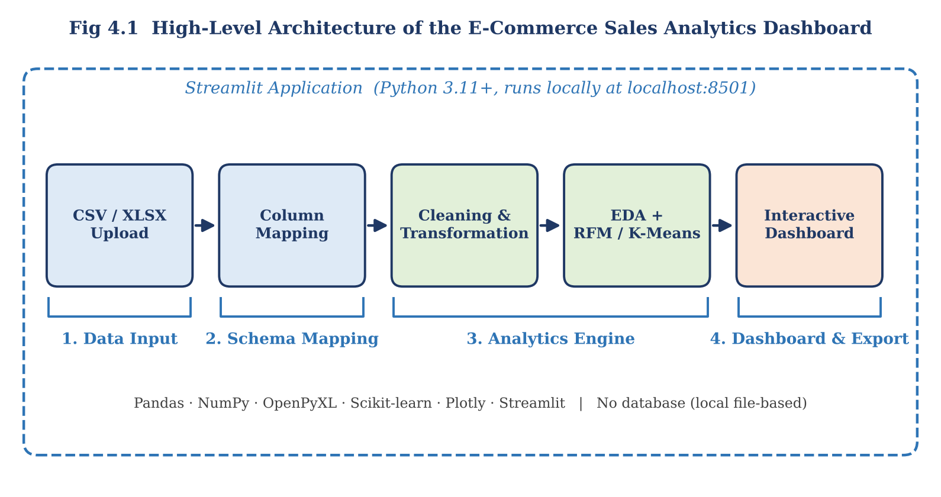
Fig 4.1: High-level architecture of the system
The architecture follows this sequence:
CSV / XLSX Upload → Column Mapping → Cleaning & Transformation → EDA + RFM / K-Means → Interactive Dashboard

4.2 Description of System Modules
1. Data Input
This component allows the user to upload a CSV or Excel file or to select the reference dataset. The file is read into a DataFrame and a preview of the rows is displayed.
2. Schema Mapping
The source column headers are connected to the standard fields used by the analysis (date, order ID, product, customer, quantity, unit price or revenue, and region). This separates the structure of the file from the analysis logic, so the same workflow can be reused for different datasets.
3. Analytics Engine
This component cleans and transforms the data, calculates KPIs and trends, and performs exploratory analysis. When customer-level fields are available it also builds RFM features and applies K-Means clustering.
4. Dashboard & Export
The results are presented through KPI cards, interactive charts, tables and customer segment views, and can be exported for further use.

4.3 Application Execution Architecture
The application is designed to run locally on a Windows machine using Python and Streamlit. The user starts the application from the project directory; Streamlit launches a local web server and the dashboard is opened in a browser at localhost:8501.
All processing takes place on the user's computer. The uploaded dataset is held in memory, no external database is contacted, and no data is sent to a remote server.
CHAPTER 5

Design

5.1 User Interface Design and Screenshots
The application is designed with a simple, step-by-step interface in which the user moves from loading the data to exploring the results. The main interface contains the following sections:
1. Dataset Upload Section
Allows the user to upload a CSV or Excel file or select the reference dataset.
2. Dataset Profile and Preview
Displays the row count, column count, missing values, sample rows and the detected field mappings after upload.
3. Column Mapping Panel
Lets the user connect the headers of the file to the standard fields.
4. Sales KPI Overview
Displays revenue, orders, customers and units once a dataset is loaded.
5. Sales Trend and Product Analysis
Displays time-based revenue and order trends and product and region performance.
6. Customer Segmentation View
Displays RFM features, K-Means clusters and the silhouette score when the required fields are available.
Insert the screenshots of the actual working application under this section.
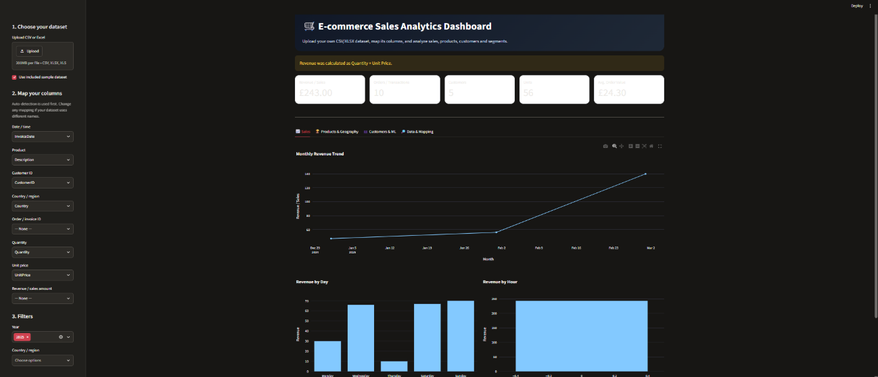
Dashboard overview
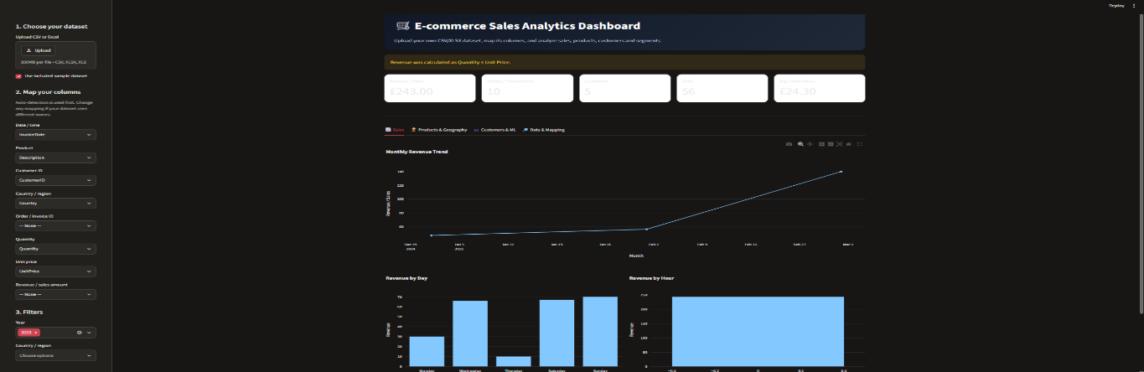

Sales KPI overview and trend charts
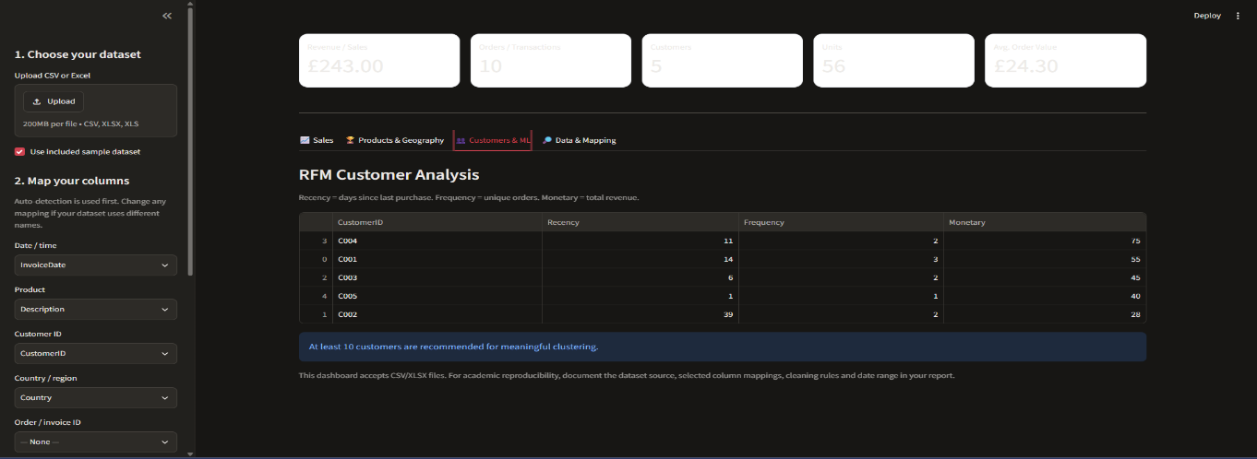

Customer segments (RFM + K-Means)

5.2 System Workflow / Data Flow Diagram
A Data Flow Diagram represents how data moves through the system. The user supplies a CSV or Excel file, which is read into a DataFrame and passed to the column-mapping step. After mapping, the data is preprocessed and validated. The clean dataset is then used to calculate KPIs and exploratory charts. If customer, date and value fields are available, RFM features and K-Means clusters are also produced. All results are shown on the interactive dashboard.
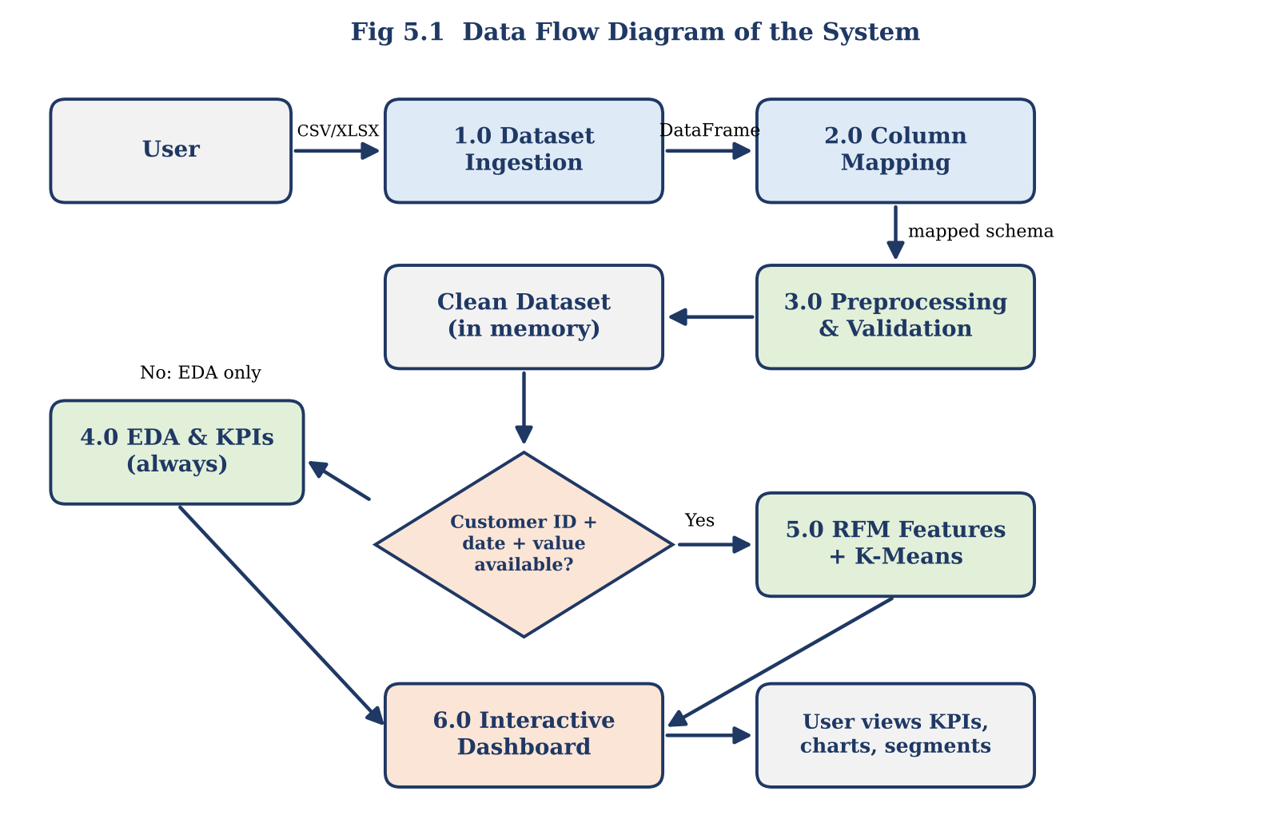
Fig 5.1: Data flow diagram
The overall data flow is:
Raw CSV / Excel file → Cleaning and analysis → Interactive sales dashboard
CHAPTER 6

Implementation

6.1 Module-wise Implementation
The project is divided into four major modules.
Module 1: Dataset Ingestion
This module reads the uploaded CSV or Excel file and previews the rows.
Input: CSV / XLSX file. Output: DataFrame.
Module 2: Column Mapping
This module connects the source headers to the standard fields used by the analysis.
Input: Column headers. Output: Mapped schema.
Module 3: Preprocessing and EDA
This module cleans the data and calculates KPIs, distributions and trends.
Input: Raw rows. Output: Clean dataset and charts.
Module 4: Customer Segmentation
This module builds RFM features and groups customers using K-Means when the required fields exist.
Input: Customer transactions. Output: Customer segments.

6.2 Dataset Upload and Column Mapping
The user uploads a CSV or Excel file. CSV files are read directly with Pandas, and Excel workbooks are read through OpenPyXL. After the upload, a dataset profile is generated showing the number of rows and columns, the missing values, a sample of the data and the detected field mappings.
Because different datasets use different column names, the application maps each source column to a standard field. The fields supported are:
Standard Field | Purpose
Date | Time-based trends and the recency calculation
Order ID | Counting orders and the frequency calculation
Product | Product-level performance
Customer | Customer counts and RFM / K-Means segmentation
Quantity | Units sold and revenue calculation
Unit Price / Revenue | Revenue and the monetary calculation
Region | Regional performance
Not every file contains every field. Fields that are not present stay unavailable, and the modules that depend on them are disabled rather than producing invented values.

6.3 Data Preprocessing
Preprocessing prepares the mapped data for analysis. The pipeline is: read file → standardize headers → map fields → parse types → validate → remove duplicates → calculate derived revenue and RFM features.
Standardizing Column Names:
Column names are cleaned to a consistent format so that the mapping and later steps are reliable.
Type Conversion:
Date, quantity and price fields are converted to suitable data types. Invalid dates and numbers are detected during this step.
Duplicate Removal:
Exact duplicate rows are removed.
Validation:
Records with non-positive quantities or prices are flagged, and the count of missing values is reviewed.
Derived Revenue:
When a revenue column is not supplied, it is calculated as Quantity × Unit Price.

6.4 KPI Calculation and Exploratory Analysis
After cleaning, the dashboard calculates the main indicators: total revenue, number of orders, number of unique customers and units sold. Exploratory analysis then examines:
- Revenue distribution and quantity and unit-price checks.
- Revenue and orders over time using time-based resampling.
- Top products by revenue and quantity.
- Performance by region, where a region field exists.
These results are displayed as interactive Plotly charts, so the user can hover, zoom and filter the data.

6.5 RFM Feature Generation
RFM analysis summarizes the purchasing behaviour of each customer using three measures:
- Recency: the number of days since the customer's most recent purchase, measured from a reference (snapshot) date.
- Frequency: the number of orders placed by the customer.
- Monetary: the total amount spent by the customer.
RFM features are generated only when the customer, date and order or revenue fields are present. Records without a customer identifier cannot be assigned to a customer, so incomplete customer IDs reduce RFM coverage.

6.6 K-Means Customer Segmentation
K-Means is an unsupervised clustering algorithm. It divides the customers into k groups by assigning each customer to the nearest cluster centre and repeatedly updating the centres. It is chosen here because customer groups are not labelled in advance.
The implementation follows these steps:
- Build the RFM table from the clean transaction data.
- Scale the Recency, Frequency and Monetary features with StandardScaler.
- Fit K-Means for a set of candidate cluster counts using a fixed random_state for repeatability.
- Compare the candidate counts using the silhouette score and interpretability.
- Assign each customer a cluster label and display the cluster profiles in the dashboard.
Because the model is unsupervised, no train/test split is used, and K-Means is applied to the available customer records. The core logic is:
# Example processing logic
sales['Revenue'] = sales['Quantity'] * sales['UnitPrice']
rfm = build_rfm(sales)
X = StandardScaler().fit_transform(rfm)
labels = KMeans(n_clusters=k, random_state=42).fit_predict(X)
CHAPTER 7

Features

7.1 List of Main Features
The major features of the application are:
- CSV and Excel dataset upload.
- Dataset profile: rows, columns, missing values and sample data.
- Configurable column mapping.
- Automatic cleaning and data-quality checks.
- Sales KPI overview (revenue, orders, customers and units).
- Interactive time, product and region analysis.
- RFM feature generation and K-Means customer segmentation.
- Silhouette-based evaluation of cluster quality.

7.2 Working of Each Feature
Dataset Upload:
The user selects a CSV or Excel file. The application reads it and shows a preview.
Column Mapping:
The user connects the file's headers to the standard fields. The mapping is then used by every later step.
Cleaning and Validation:
Column names are standardized, types are converted, duplicates are removed and invalid quantities and prices are flagged.
KPI Overview:
Revenue, orders, customers and units are calculated from the clean dataset.
Trend and Product Analysis:
Charts show how revenue and orders change over time and which products or regions perform best.
Customer Segmentation:
RFM features are computed, scaled and clustered with K-Means, and the segments are displayed with their silhouette score.

7.3 Dataset-Flexible Input
The main contribution of the project is that column mapping is kept separate from the analysis. A user can bring a different retail transaction file, map its columns once and reuse the same workflow, rather than rewriting the analysis code for each dataset.
Modules that depend on missing fields are disabled gracefully. For example, if the file has no customer identifier, the KPI and trend analysis still works, but customer segmentation is switched off.

7.4 Customer Segmentation Dashboard
When customer-level data is available, the segmentation view shows the RFM features, the cluster assigned to each customer and the profile of each cluster. From these, the user can identify high-revenue customers, repeat buyers and customers who have not purchased recently, which supports retention and campaign planning.
CHAPTER 8

Testing

8.1 Functional Testing
Functional testing verifies that the main features work as expected. The following operations are tested:
- Uploading a valid CSV file and an Excel file.
- Parsing the file and displaying the preview.
- Mapping the required date and revenue fields.
- Preprocessing the data and calculating KPIs.
- Rendering the sales charts.
- Generating RFM features and K-Means segments.
- Handling files with missing optional fields.

8.2 Integration Testing
Integration testing checks whether the modules work together correctly. The following sequence is verified:
- The user uploads a dataset and the ingestion module reads it.
- The mapped schema is passed to the preprocessing module.
- The clean dataset is used to calculate KPIs and charts.
- When customer fields exist, RFM features are passed to K-Means.
- All results are displayed on the dashboard.

8.3 Tools Used for Testing
- Python for executing the application.
- Streamlit for testing the user interface in the browser.
- Pandas for checking calculated revenue and aggregates against known sample rows.
- Scikit-learn (silhouette score) for evaluating cluster quality.
Postman testing is not applicable because the application does not use a separate REST API backend.

8.4 Test Cases and Results
The test cases below are used to validate the application. The Actual Result and Status columns are to be recorded during execution.
Test ID | Test Description | Expected Result | Actual Result | Status
TC-01 | Upload valid CSV | File loads and preview appears | To be recorded | Pending
TC-02 | Upload valid Excel file | Workbook is read successfully | To be recorded | Pending
TC-03 | Map required date / revenue fields | KPIs and time charts calculate | To be recorded | Pending
TC-04 | Upload file with missing optional fields | Unavailable modules are disabled gracefully | To be recorded | Pending
TC-05 | Upload file with duplicate rows | Exact duplicates are removed | To be recorded | Pending
TC-06 | Upload file with invalid dates or non-positive quantities | Invalid records are flagged | To be recorded | Pending
TC-07 | Run segmentation on file with customer ID, date and value | RFM features and K-Means clusters are produced | To be recorded | Pending
Validation method: data validation using known sample rows and manual spot-checks of calculated revenue and aggregates; silhouette score for clustering.
Performance check: successful parsing, responsive filtering and completion of the dashboard calculations for the selected file.

8.5 Model Performance Evaluation
K-Means is an unsupervised method and the dashboard performs descriptive analytics, so classification metrics such as accuracy, precision, recall, F1-score and ROC-AUC, and a confusion matrix, do not apply to this project. No fixed performance figures are claimed, because the results depend on the dataset uploaded.
Cluster quality is assessed using the silhouette score, and the application reports the actual values for the selected dataset. For the final evaluation run, the following details are recorded:
Item | Value for the selected dataset
Dataset used | [Record dataset name]
Number of records (rows) | [Record from dataset profile]
Number of columns | [Record from dataset profile]
Number of customers with RFM data | [Record from segmentation view]
Selected number of clusters (k) | [Record]
Silhouette score | [Record]
A high silhouette score indicates well separated clusters, but the score assesses cluster structure only. The usefulness of the segments is also judged from how easily each cluster can be interpreted in business terms.
CHAPTER 9

Deployment

9.1 Steps to Run the Application
The application is executed locally using the following steps:
- Install Python 3.11 or later on the computer.
- Open the project folder in Visual Studio Code or Command Prompt.
- Create a Python virtual environment.
- Activate the virtual environment.
- Install the required Python libraries.
- Run the Streamlit application.
Command to execute the application:
python -m streamlit run app.py
After the command is executed, Streamlit displays a local URL (localhost:8501) in the terminal. Open that URL in a web browser to access the dashboard.

9.2 Python Environment Configuration
The project uses a Python virtual environment to manage its libraries. The environment contains Streamlit, Pandas, NumPy, OpenPyXL, Scikit-learn and Plotly. The libraries are installed from the project's requirements file, which keeps the setup repeatable on other machines.
An internet connection is needed only for the initial package installation and for the optional download of the reference dataset.

9.3 Local Application Execution
The dashboard runs locally on a Windows machine. The user interface and the analysis logic run within the same Python application, so separate front-end and back-end hosting is not required. No database or payment system is connected.
CHAPTER 10

Challenges and Limitations

10.1 Issues Faced During Development
Different Column Names:
Transaction files from different sources use different names for the same information.
Missing or Invalid Values:
Files contain missing fields, invalid dates and numbers, duplicates and non-positive quantities or prices.
Scale Sensitivity of Clustering:
K-Means is sensitive to the scale of its input features, and RFM features have very different ranges.
Incomplete Customer Data:
Missing customer IDs and sparse purchase histories reduce the coverage of RFM analysis.

10.2 Solutions Applied
- Configurable field mapping was added so that different column names can be handled.
- Validation and safe handling of unavailable fields were added, so missing optional fields remain unavailable instead of being fabricated.
- RFM features are standardized with StandardScaler before K-Means.
- The silhouette score and interpretability are used to compare candidate cluster counts.
- A fixed random_state is used so that clustering results are repeatable.
- Customer segmentation is enabled only when the required fields exist.

10.3 Current Limitations
- The quality of the analysis depends on the completeness and consistency of the uploaded dataset.
- RFM and K-Means need customer identifiers and transaction-level date and value information.
- The current version is a local dashboard; it does not connect to live store databases or payment systems.
- The project provides descriptive and customer analytics; predictive demand forecasting is not included.
- Very large files may be slow to process because the data is held in memory.
CHAPTER 11

Future Enhancements

11.1 Planned Features
The project can be extended in several ways.
Multi-file Merging:
Allow several transaction files to be combined before analysis.
Currency Handling:
Support datasets containing more than one currency.
Product Category Mapping:
Add category-level analysis through category mapping.
Additional Datasets:
Test and extend the tool with further retail datasets.
Downloadable Reports:
Generate reports that users can download.

11.2 Improving the Clustering Approach
K-Means can be compared with other methods such as hierarchical clustering or DBSCAN. The cluster count can be tuned more carefully, and performance on large files can be improved.

11.3 Hosted Deployment and Security
The dashboard can be deployed to a secure hosted environment so that users do not need a local installation. A hosted version should add authentication, access control, audit logs and scalable data storage.
Applications
- Retail store sales monitoring.
- E-commerce product and regional performance review.
- Customer retention and campaign planning.
- Use by small retailers, e-commerce analysts, business students and marketing teams.
CHAPTER 12

Conclusion

12.1 Summary of the Project
The project “E-Commerce Sales Analytics Dashboard” was developed as an interactive data science application. It allows users to upload CSV or Excel transaction files, map their columns to a standard schema, clean and validate the data, and explore sales through interactive visualizations.
Where customer, date and value fields are available, the application also generates RFM features and groups customers using K-Means clustering, with cluster quality assessed through the silhouette score. Numerical results vary with the uploaded dataset.
The workflow reduces repeated manual preparation and lets users explore different transaction datasets through one interface. The project demonstrates how data preprocessing, exploratory analysis and clustering can be combined into a practical analytical tool.

12.2 Achievements
The major achievements of the project include:
- Developed a Streamlit dashboard that accepts CSV and Excel transaction datasets.
- Created a reusable preprocessing pipeline with column mapping, type conversion and data-quality checks.
- Explored revenue, orders, products, regions and time-based patterns through interactive visualizations.
- Generated RFM features and applied K-Means clustering when customer and transaction fields are available.
All four core objectives of the project (4 of 4) were implemented. This reflects feature coverage and is not a model accuracy score.

12.3 Skills Learned During Development
Through this project, we gained practical experience in:
- Python programming.
- Data cleaning and preprocessing with Pandas and NumPy.
- Exploratory data analysis and interactive visualization with Plotly.
- RFM analysis and K-Means clustering with Scikit-learn.
- Evaluating clusters with the silhouette score.
- Streamlit application development.
- Team collaboration and technical documentation.
CHAPTER 13

References
[1] J. MacQueen, “Some Methods for Classification and Analysis of Multivariate Observations,” in Proc. 5th Berkeley Symp. Mathematical Statistics and Probability, 1967, pp. 281–297.
[2] P. J. Rousseeuw, “Silhouettes: A graphical aid to the interpretation and validation of cluster analysis,” Journal of Computational and Applied Mathematics, vol. 20, 1987, pp. 53–65.
[3] A. Hughes, Strategic Database Marketing. Chicago, IL, USA: Probus Publishing, 1994.
[4] D. Chen, S. Sain, and K. Guo, “Data mining for the online retail industry: A case study of RFM model-based customer segmentation using data mining,” Journal of Database Marketing & Customer Strategy Management, vol. 19, 2012.
[5] UCI Machine Learning Repository, “Online Retail,” 2015. [Online]. Available: https://doi.org/10.24432/C5BW33
[6] Streamlit, “Streamlit documentation.” [Online]. Available: https://docs.streamlit.io/
[7] scikit-learn developers, “KMeans and clustering performance evaluation documentation.” [Online]. Available: https://scikit-learn.org/stable/
Project Links
- GitHub: [Add repository URL]
- Dataset: https://doi.org/10.24432/C5BW33 (UCI reference)
- Demo video: [Add link after recording]
CHAPTER 14

Appendices

14.1 Application Screenshots
The following screenshots demonstrate the working of the application:
- Dataset upload and preview.
- Column mapping panel.
- Sales KPI overview.
- Sales trend charts.
- Product and region analysis.
- Customer segments (RFM + K-Means) and silhouette score.

14.2 Sample Code Snippets
The following is a simplified example of the RFM feature generation and K-Means clustering used in the project.
import pandas as pd
from sklearn.preprocessing import StandardScaler
from sklearn.cluster import KMeans
from sklearn.metrics import silhouette_score

# Derived revenue
sales['Revenue'] = sales['Quantity'] * sales['UnitPrice']

# RFM features per customer
snapshot = sales['Date'].max() + pd.Timedelta(days=1)
rfm = sales.groupby('CustomerID').agg(
Recency=('Date', lambda x: (snapshot - x.max()).days),
Frequency=('OrderID', 'nunique'),
Monetary=('Revenue', 'sum'))

# Scale features and cluster
X = StandardScaler().fit_transform(rfm)
labels = KMeans(n_clusters=k, random_state=42).fit_predict(X)
score = silhouette_score(X, labels)

14.3 Installation and Setup Instructions
Step 1: Install Python 3.11 or later.
Step 2: Open the project folder in Visual Studio Code or Command Prompt.
Step 3: Create and activate the virtual environment.
python -m venv venv
.\venv\Scripts\Activate.ps1
Step 4: Install the required libraries.
pip install -r requirements.txt
Step 5: Run the application.
python -m streamlit run app.py
Step 6: Open the local URL displayed in the terminal (localhost:8501).

14.4 User Manual
The application can be used through the following steps:
- Open the Streamlit application in a browser.
- Upload a CSV or Excel transaction file, or select the reference dataset.
- Review the dataset profile and sample rows.
- Map the columns of the file to the standard fields.
- View the sales KPIs and the trend, product and region charts.
- If customer fields are available, open the customer segmentation view.
- Review the RFM clusters and the silhouette score.

14.5 Team Contributions
Reg. No. | Name | Contribution / Modules Handled
2420030701 | P. Roshan | Project concept, dashboard workflow, data ingestion, preprocessing, analytics integration and presentation.
2420030791 | Om Pandey | Sales dashboard
2420030704 | P.V.V. Satya Sai | Customer dashboard
2420039804 | Vadde Tharun Kumar
All team members contributed to project integration, testing, debugging and documentation according to their actual work.

